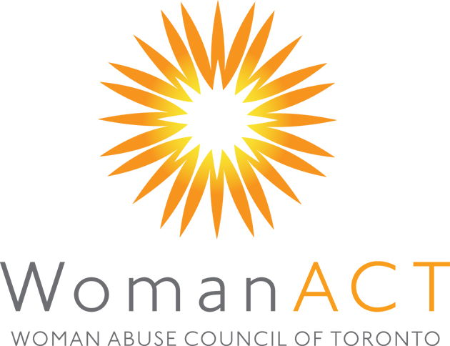
Application to the Board of Directors

Please complete this application. Use additional pages if required.
Name:

Home Address

phone | fax | e-mail
Work (if applicable) Company & Address

phone | fax | e-mail
Summarize your experience with and/or interest in our organization.

What skills and knowledge are you willing to bring to our board? Please indicate your experience in the following areas. | very experienced | some experience | little or no experience
Knowledge of Woman Abuse
Resource Development
Governance (recruitment, training, evaluation)
Program planning and evaluation
Human Resources
Financial management and control (budgeting, accounting)
Communication, public and media relations;
Participation in interagency committees.
Public speaking
Organizational development
Information technology
Writing, journalism
Special events (planning and implementing)
Strategic planning
Knowledge of Corporate Law
For the items you checked as “very experienced” or “some experience”, please provide details.

If not described above, please outline your experience as a volunteer board or committee member?

Who may we contact for information about your performance in these positions?

Please attach your resume. Mail, fax, or e-mail completed application to Attn: Nominating Committee,
Woman Abuse Council of Toronto, Fax 416-944-9753, Email: ed@womanabuse.ca

